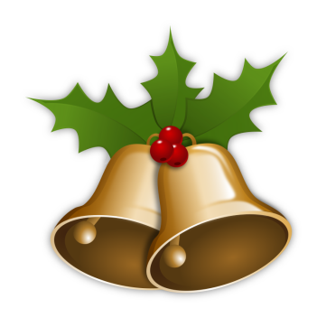
Chistmas Buffet Menu

Basket of freshly baked bread rolls

Cold Platters
Roast turkey breast with red current & orange and cranberry glaze
Sliced double smoked leg ham with assorted mustards
Beef Sirloin roasted with ginger, garlic & sesame with honey soy sauce
Smoked salmon with citrus dill sour cream mayo
Grilled Cajun chicken breast with lime, avocado & chilli salsa
Anti-Pasto platter of grilled, roasted vegetables, cheese & char grilled octopus marinated prawns and salami

Salads
Tossed garden salad
Roasted chat potato salad
Mediterranean pasta salad
Crunchy noodle & wombok salad with Thai dressing
Ceasar style salad.

Dessert Buffet
Hot plum pudding with brandy custard & cream
Fresh seasonal fruit platter
Gourmet Cheese Platter
Tea and Coffee Station

